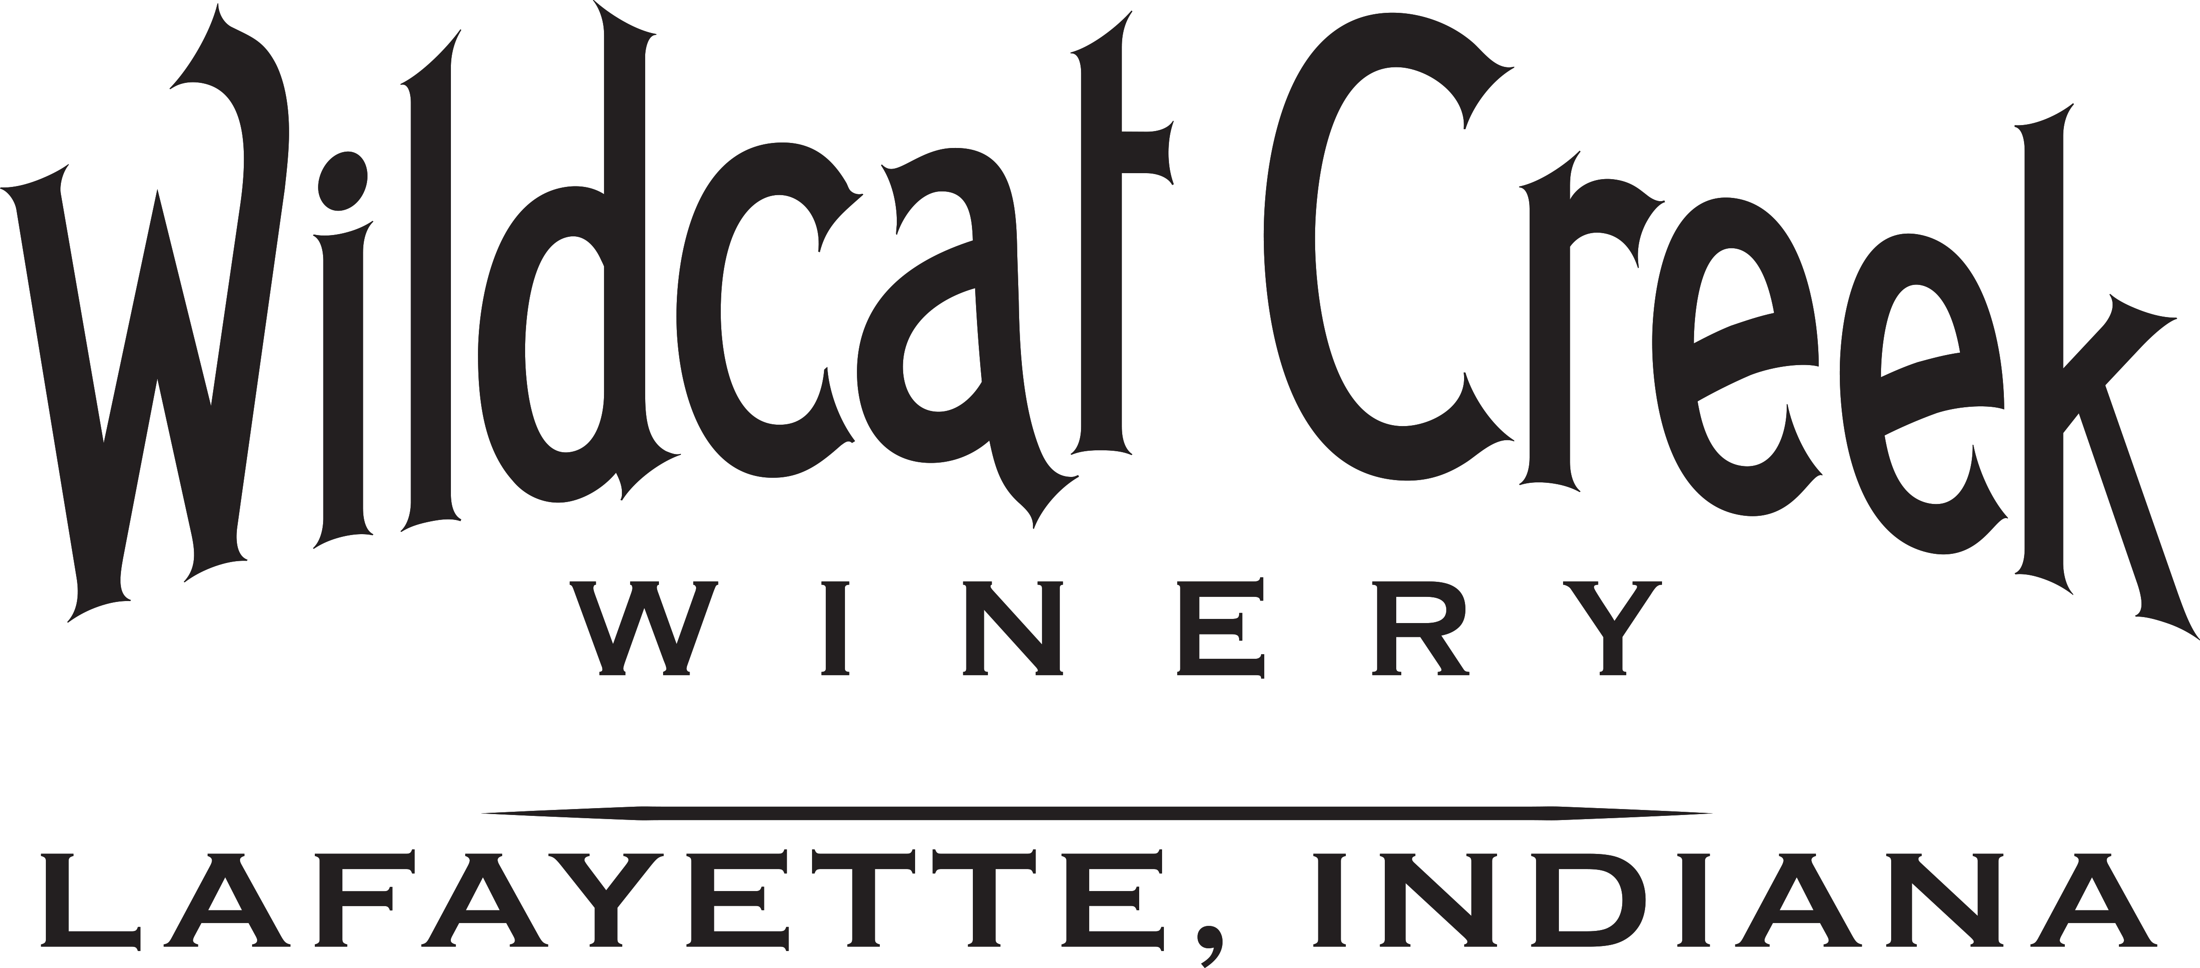 (765) 838-3498
Email applications & resumes to info@wildcatcreekwinery.com
Personal Information
Last First MI  Name |  |  |  |  |  |  |  |  | Application Date
Street Address City, State, Zip Apt. |  |  |  |  |  |  |  |  | Home Phone | Cell Phone
Email | Referred by |  |  | Position applied for |  |  |  |  | Date Available | Salary desired
Check desired work options:  Full Time Part Time Days Evenings Weekends Holiday Breaks |  |  |  |  |  |  |  |  | Work Restrictions? List:
If no are you authorized to work in the
Are you a citizen of the United States? Yes No U.S.? Yes No
Have you ever been convicted of a Felony?  Yes No |  |  |  |  | If yes, please describe in detail:
Education and Training
High School Name |  |  |  |  |  | Address
From To |  | Did you graduate? Yes No |  |  |  |  | Degree /Major
College |  |  |  |  |  | Address
From To |  | Did you graduate? Yes No |  |  |  |  | Degree /Major
Other |  |  |  |  |  | Address
From To |  |  | Did you graduate? Yes No |  |  |  | Degree /Major
Professional References
Full Name |  |  |  |  |  | Title
Company |  |  |  |  |  | Phone ( )
Address |  |  |  |  |  | Relationship Time Known
Full Name |  |  |  |  |  | Title
Company |  |  |  |  |  | Phone ( )
Address |  |  |  |  |  | Relationship Time Known
Full Name |  |  |  |  |  | Title
Company |  |  |  |  |  | Phone ( )
Address |  |  |  |  |  | Relationship Time Known
Employment History (most recent first)
Company |  |  | Type of Business |  |  |  |  | Phone ( )
Address |  |  | From To |  |  |  |  | Full Time Part Time
Job Title/Responsibilities |  |  |  |  |  | Supervisor’s Name  May we Contact? Yes No
Salary History  Starting Ending |  |  |  |  |  | Reason for leaving
Company |  |  | Type of Business |  |  |  |  | Phone
Address |  |  | From To |  |  |  |  | Full Time Part Time
Job Title/Responsibilities |  |  |  |  |  | Supervisor’s Name  May we Contact? Yes No
Salary History  Starting Ending |  |  |  |  |  | Reason for leaving
Company |  |  | Type of Business |  |  |  |  | Phone ( )
Address |  |  | From To |  |  |  |  | Full Time Part Time
Job Title/Responsibilities |  |  |  |  |  | Supervisor’s Name  May we Contact? Yes No
Salary History  Starting Ending |  |  |  |  |  | Reason for leaving
Additional Experience
We look for knowledgeable service oriented people with the desire to learn and the ability to educate and assist our customers. If this description fits you, then start by selling yourself to us. What qualities, experience, interests and knowledge do you have that would make you a great addition to our team!
Please describe any winery experience/classes you may have had:

Please describe any sales experience you may have:
What interests you in working at Wildcat Creek Winery?
Authorization
I certify that all information contained in this application and any attachments is true and complete to the best of my knowledge. I understand that any willful misrepresentation, false statement or omission by me in the application or interview process will be cause for rejection of my application or termination of my employment. I authorize investigation of all statements made on this application and any attachments, and I release all persons, companies, and organizations from liability for providing or receiving such information. I further understand that this employment application and other employment related documents are not contracts of employment.

Signature____________________________________________________Date________________________________________
Equal Opportunity Employer
We do not discriminate on the basis of race, color, age, national origin, gender, religion, disability, gender identity, veteran’s status or sexual orientation in compliance with all Federal State and local laws.
9/09

