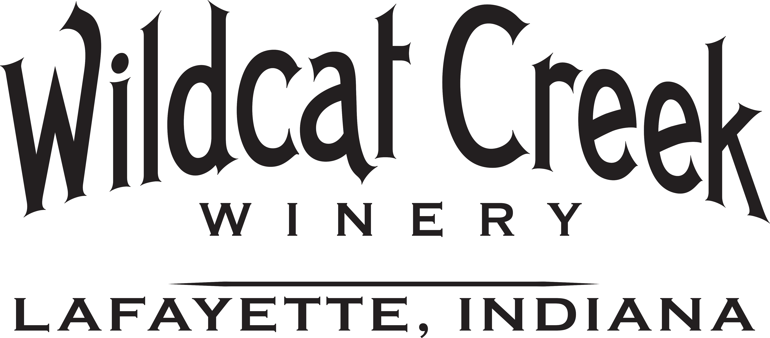
(765) 838-3498

Email this application *or* a resume to info@wildcatcreekwinery.com
Personal Information
Last Name First Name M.I. |  |  |  |  |  |  | Application Date
Street Address City, State, Zip Apt. |  |  |  |  |  |  | Phone
Email |  | Referred by |  | Position |  |  | Date Available
Check desired work options:  Full Time Part Time Weekends Weekdays |  |  |  |  |  |  | Work Restrictions
Are you authorized to work in the U.S.A.?
Yes No
Have you ever been convicted of a Felony?  Yes No |  |  |  |  | If yes, please describe:
Education and Training
High School or GED completed?  Yes No |  |  |  |  |  | From To
College |  |  |  |  |  | From To
Did you graduate?  Yes No | Degree/Major
Other |  |  |  |  |  | From To
Did you graduate?  Yes No | Degree /Major
Professional References
1) Full Name |  |  |  |  |  | Title
Company |  |  |  |  |  | Phone
Address |  |  |  |  |  | Relationship Time Known
2) Full Name |  |  |  |  |  | Title
Company |  |  |  |  |  | Phone
Address |  |  |  |  |  | Relationship Time Known
3) Full Name |  |  |  |  |  | Title
Company |  |  |  |  |  | Phone
Address |  |  |  |  |  | Relationship Time Known
Employment History (most recent first)
1) Employer |  |  |  |  |  |  |  | Phone
Address |  |  | From To |  |  |  |  | Full Time Part Time
Job Title/Responsibilities

Reason for leaving

2) Employer |  |  |  |  |  |  |  | Phone
Address |  |  | From To |  |  |  |  | Full Time Part Time
Job Title/Responsibilities

Reason for leaving

3) Employer |  |  |  |  |  |  |  | Phone
Address |  |  | From To |  |  |  |  | Full Time Part Time
Job Title/Responsibilities

Reason for leaving

Additional Experience
We are looking for knowledgeable service-oriented people with the desire to learn and the ability to assist our customers. What qualities, experience, interests, and knowledge do you have that would make you a great addition to our team!
Please describe any winery experience/classes you may have had:
Please describe any sales experience you may have:
What interests you in working at Wildcat Creek Winery?
Authorization
I certify that all information contained in this application and any attachments is true and complete to the best of my knowledge. I understand that any willful misrepresentation, false statement or omission by me in the application or interview process will be cause for rejection of my application or termination of my employment. I authorize investigation of all statements made on this application and any attachments, and I release all persons, companies, and organizations from liability for providing or receiving such information. I further understand that this employment application and other employment related documents are not contracts of employment.

Signature____________________________________________________Date________________________________________
Equal Opportunity Employer
Wildcat Creek Winery does not discriminate based on race, color, age, national origin, gender, religion, disability, gender identity, veteran’s status, or sexual orientation.

8/25

